Step1: To start the lab session, choose **Start Lab** in the upper-right corner of the page.

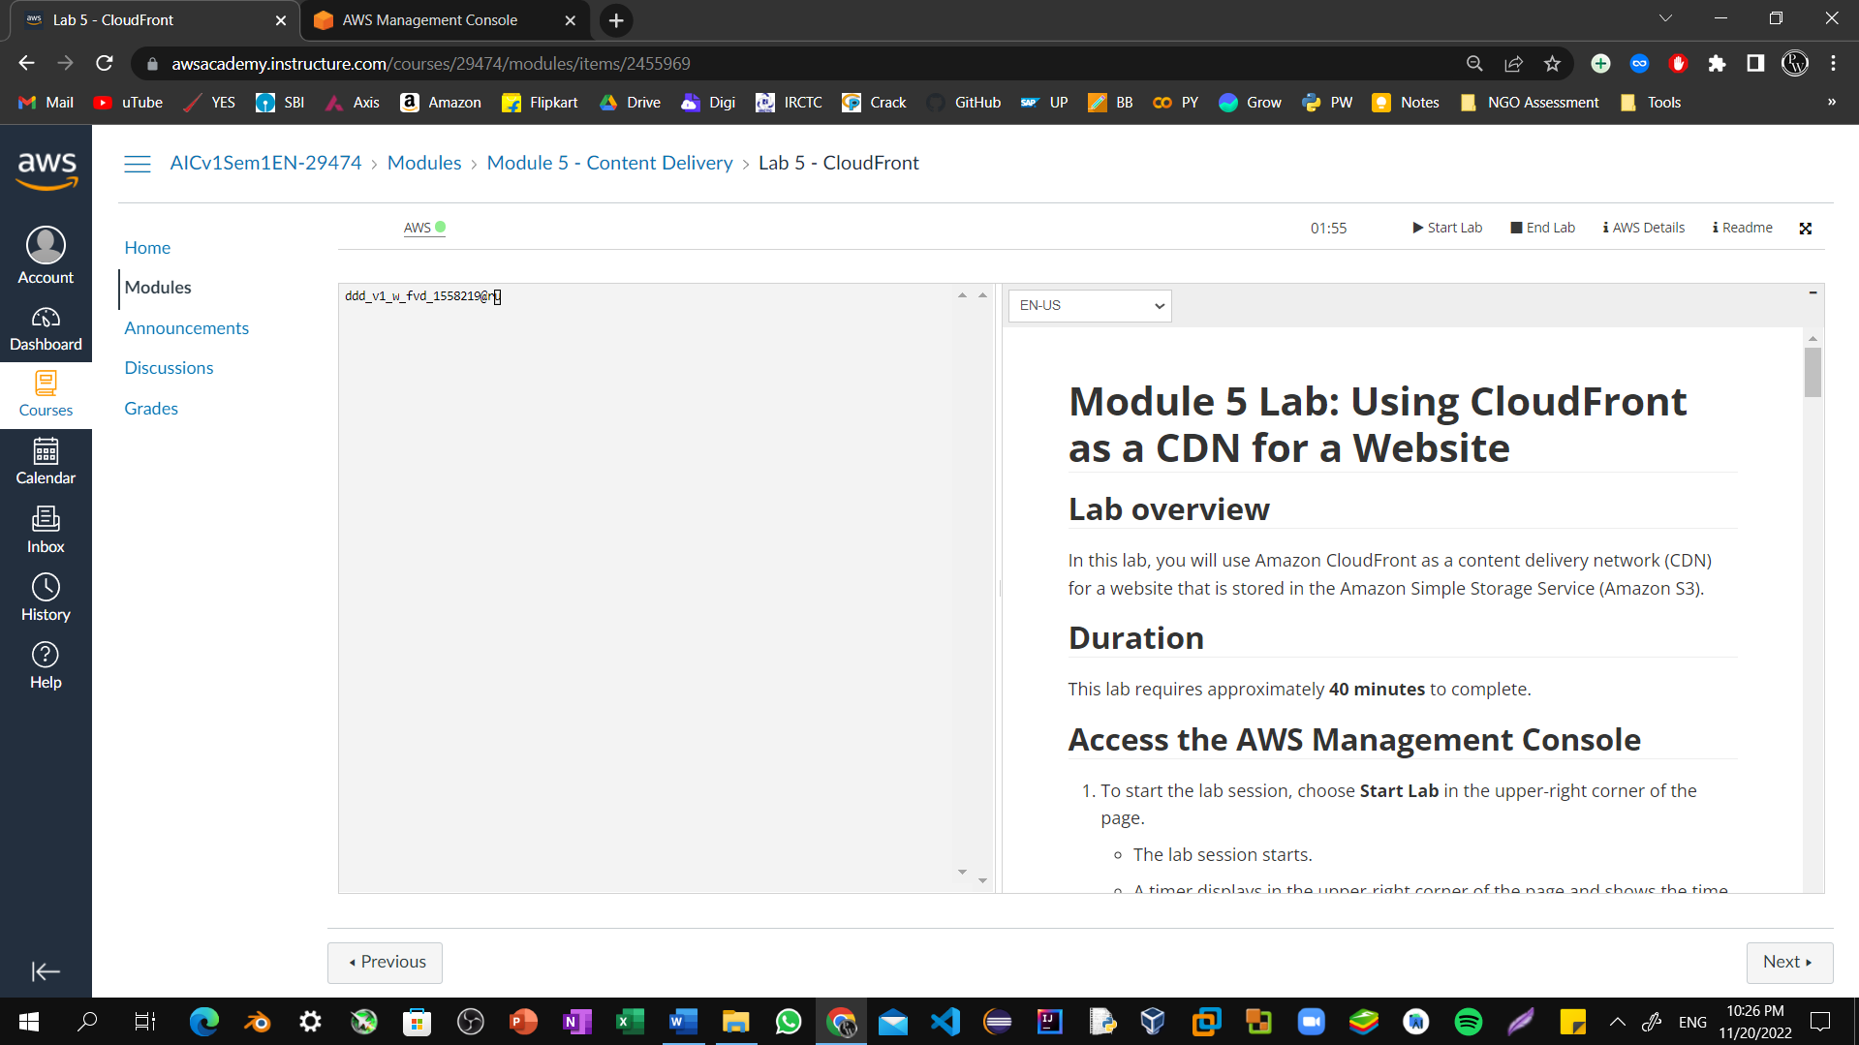

Step2: Choose the **Services** menu, locate the **Developer Tools** services, and select **CloudShell**. If a welcome pop-up window appears, choose **Close**.

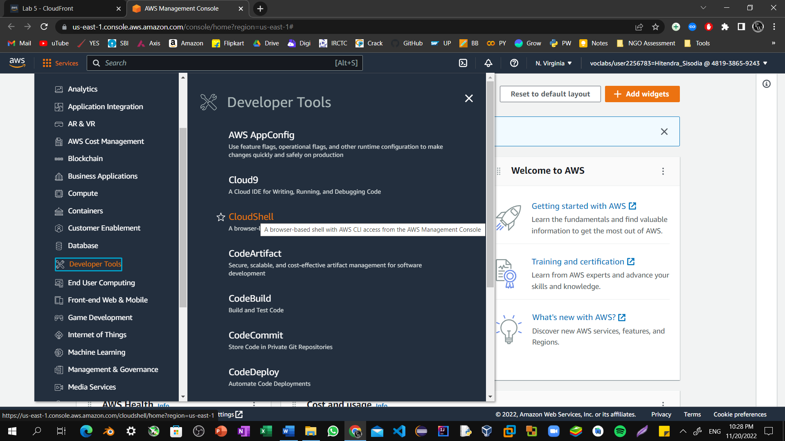

Step3: Copy and paste the following code into a text editor

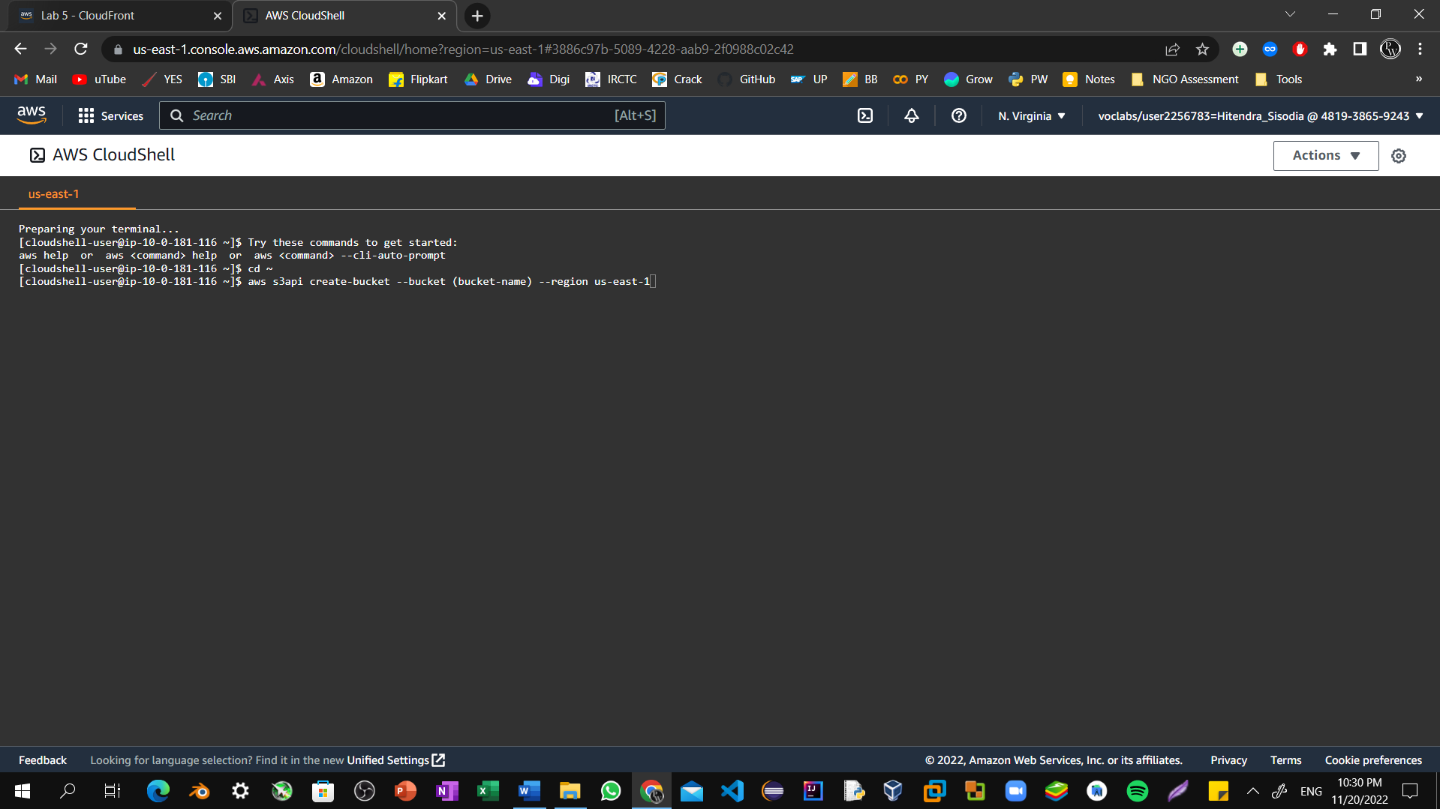

Step4: In the code that you copied, replace **(bucket-name)** with a unique Domain Name System (DNS)-compliant name for your new bucket. Run the updated code in the CloudShell terminal.If a pop-up window appears, choose **Paste**. 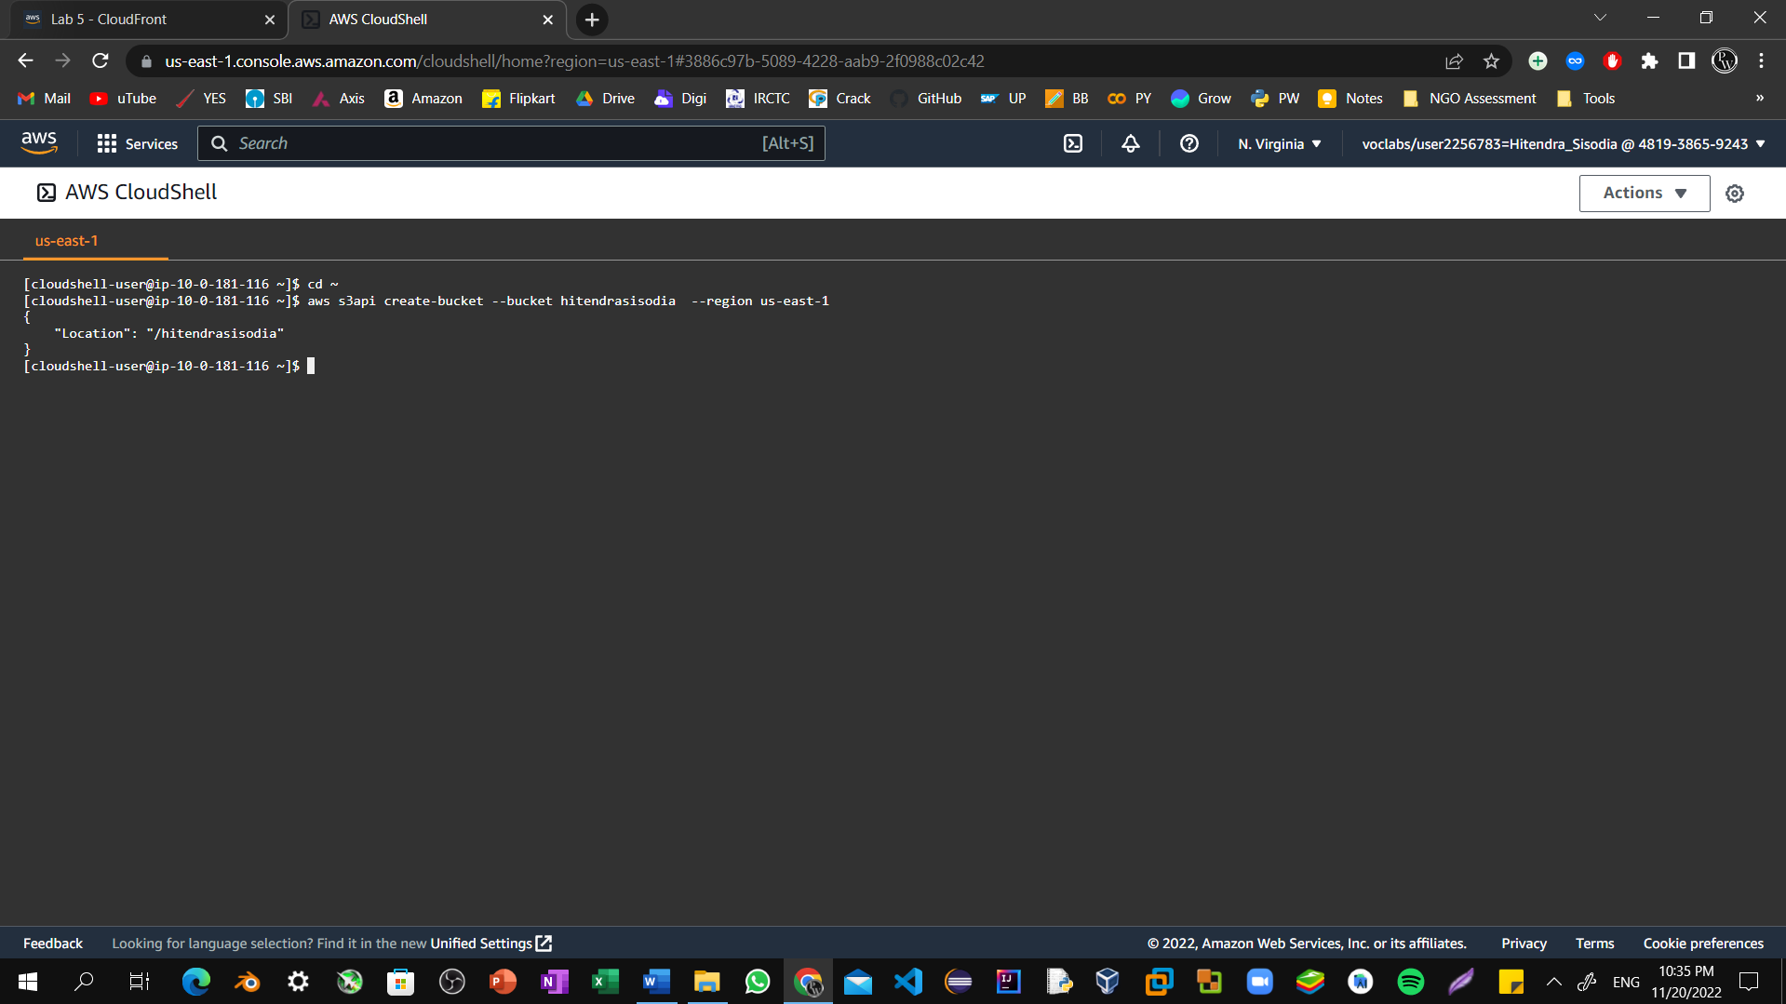

Step5: In the console, choose the **Services** menu, locate the **Storage** section, and choose **S3**.

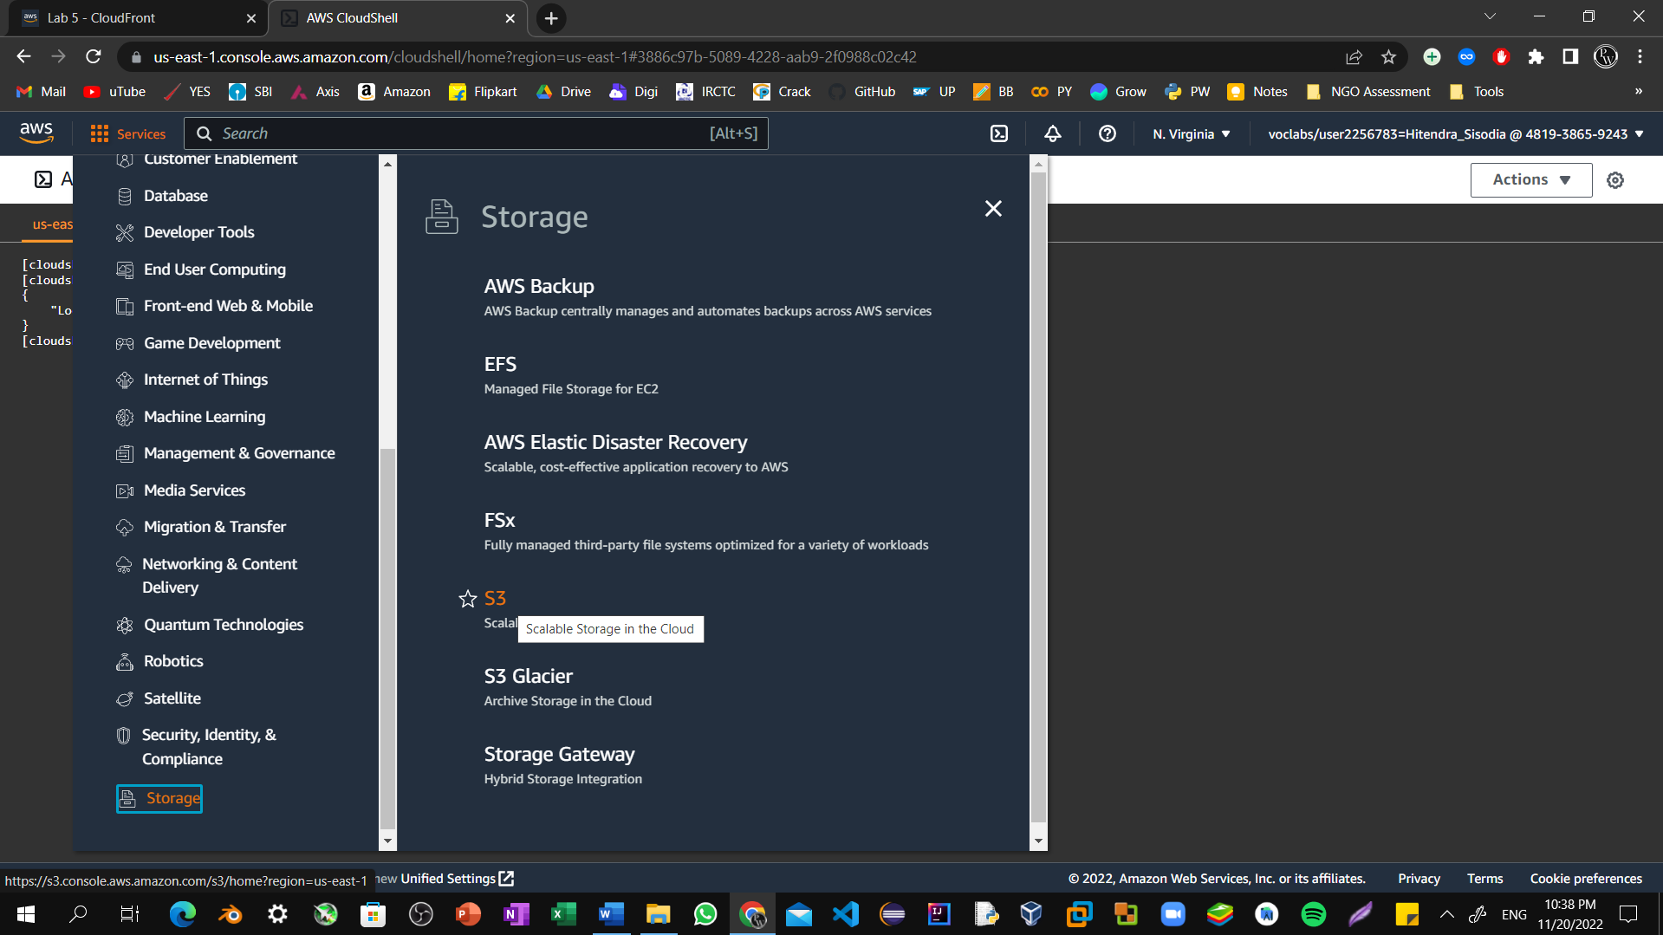

Step6: Choose the name of the bucket that you just created.

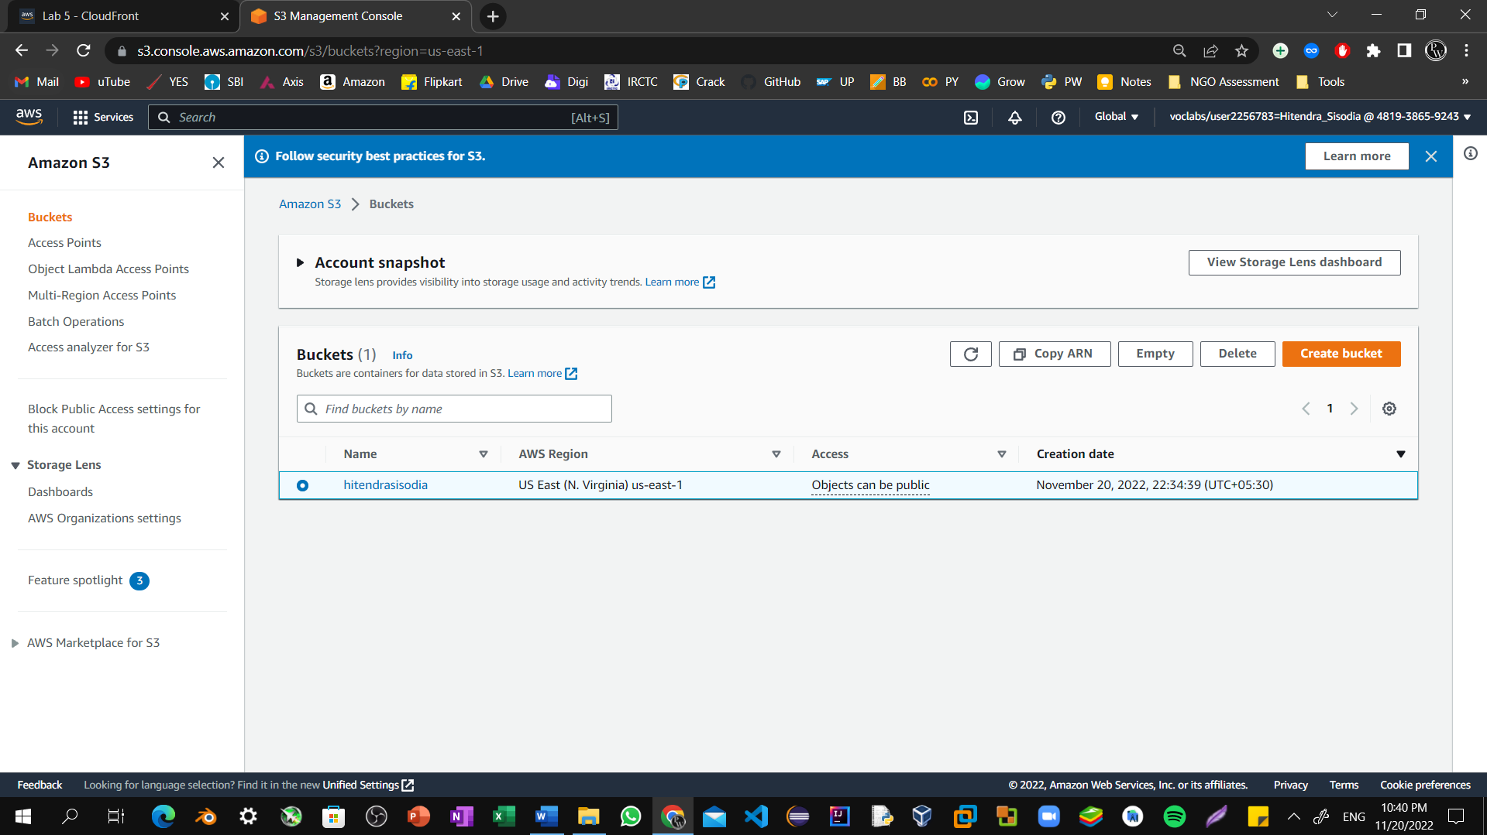

Step7: Choose the  **Permissions** tab.

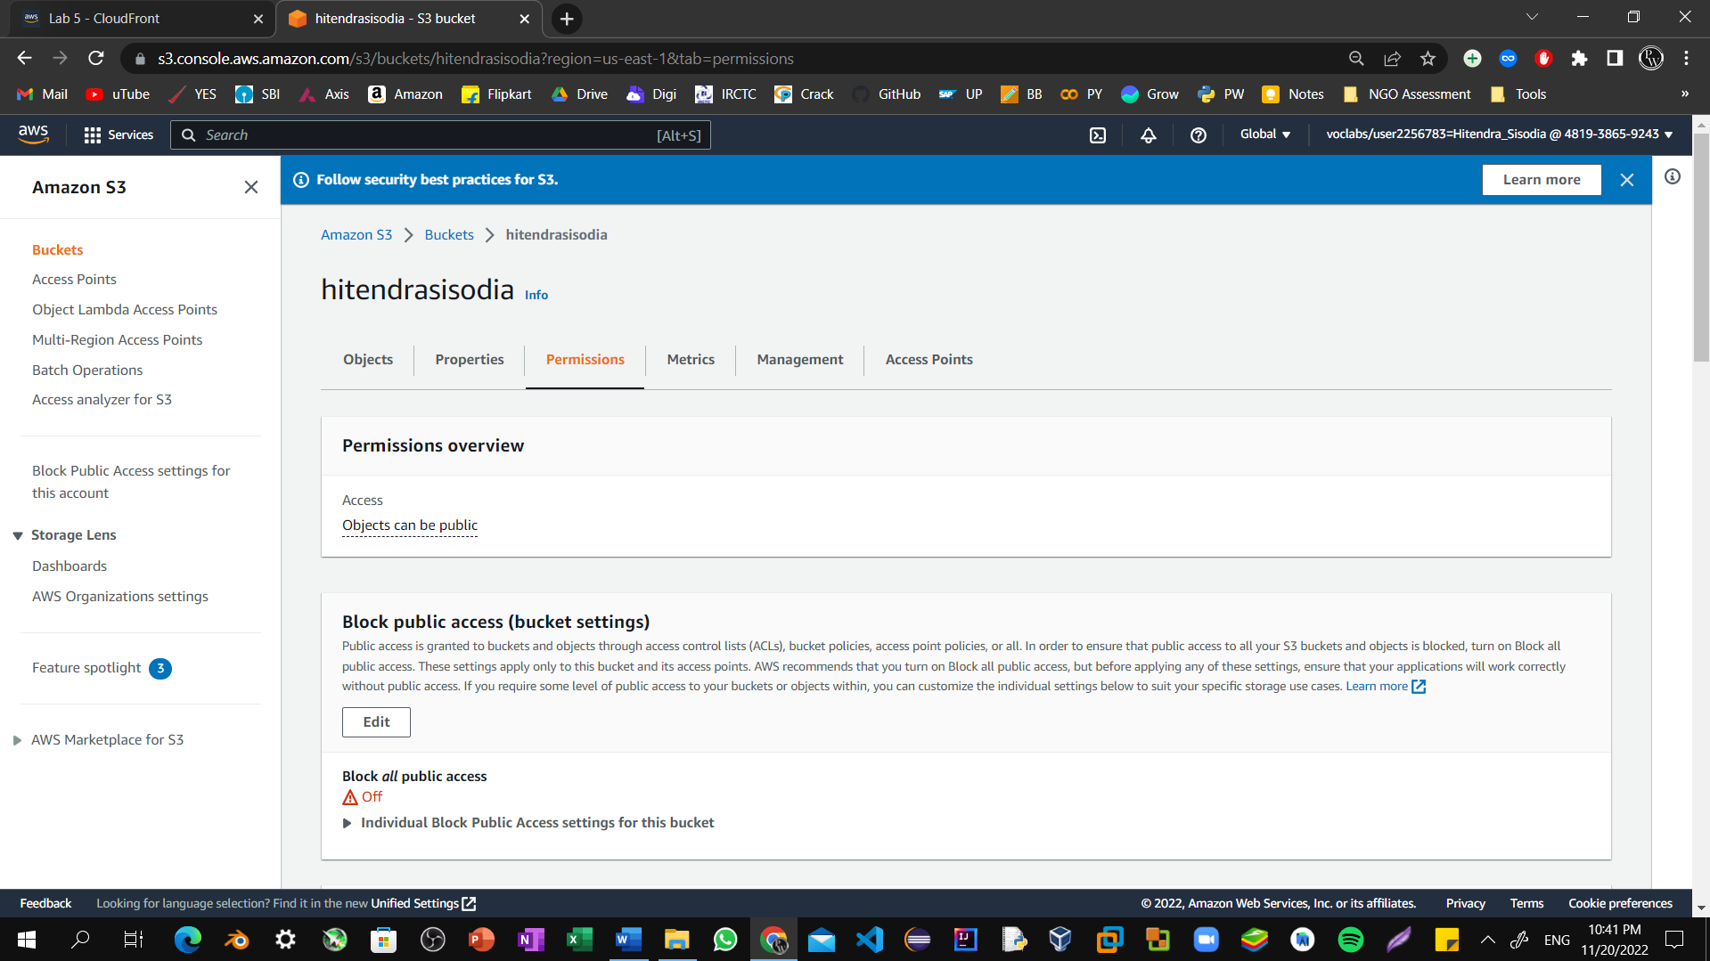

Step8: In the **Bucket policy** section, choose **Edit**.

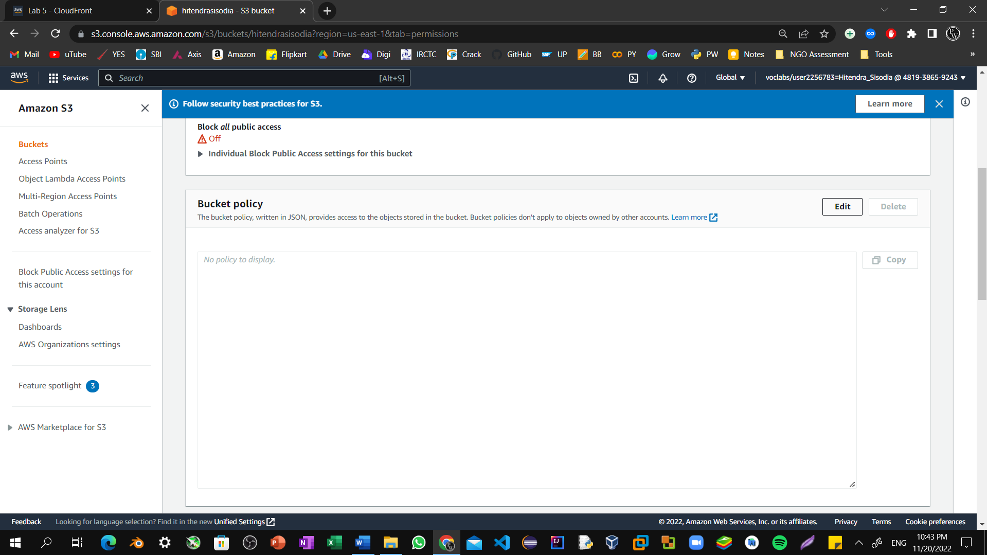

Step9: To grant public read access for your website, copy and paste the following bucket policy into the policy editor.

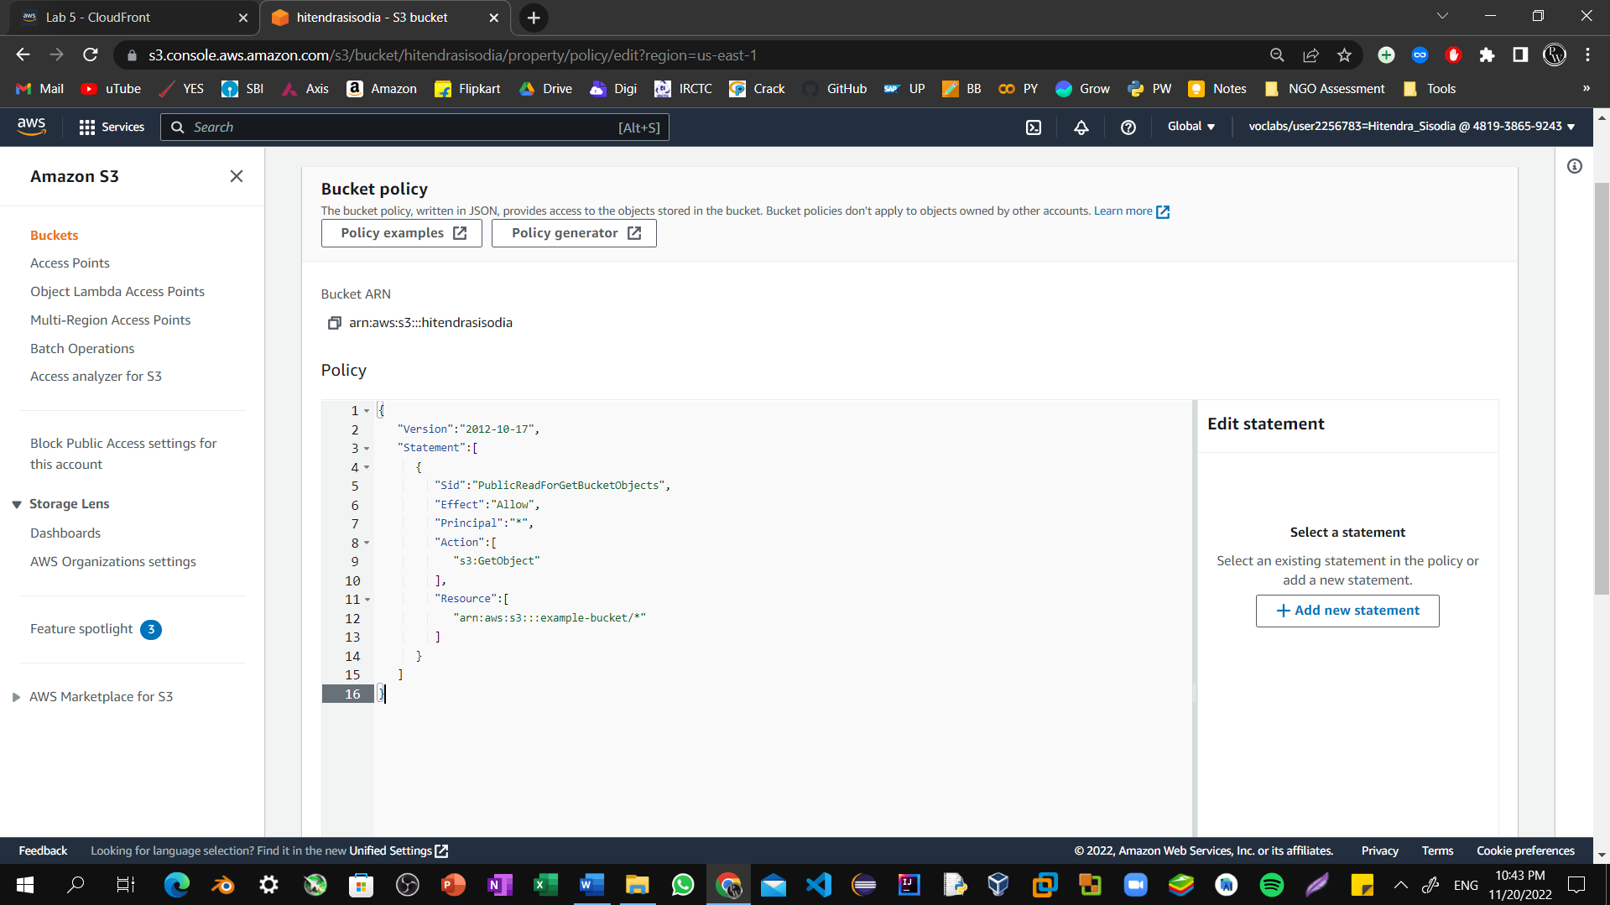

Step10: In the policy, replace **example-bucket** with the name of your bucket. At the bottom of the page, choose **Save changes**.

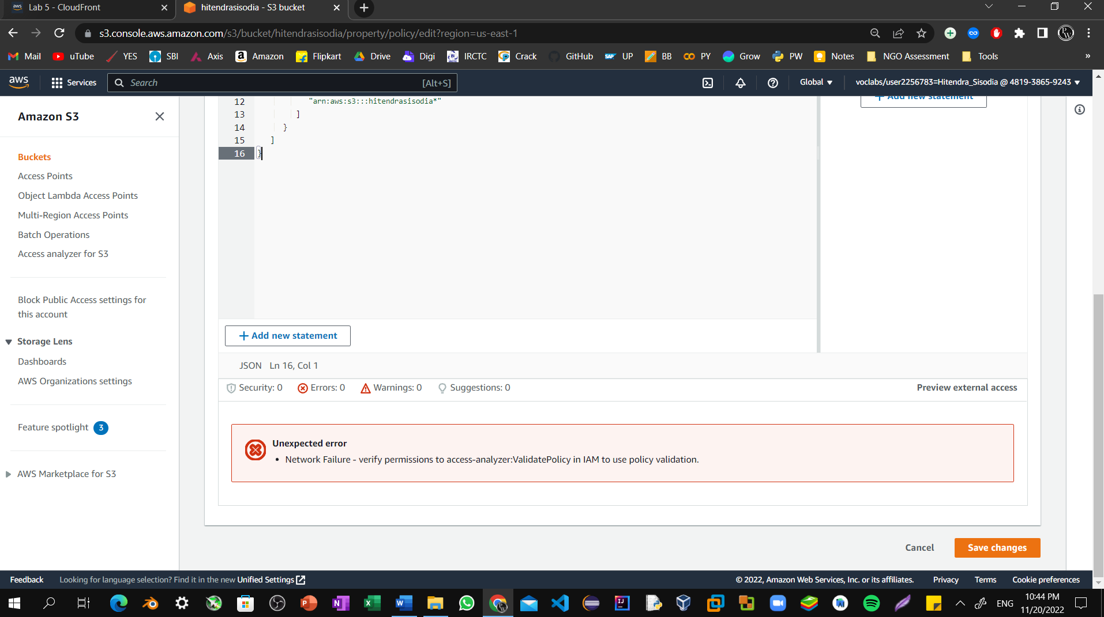

Step10: Open the context menu (right-click) for the following link, and then choose **Save link as**: [index.html](https://aws-tc-largeobjects.s3-us-west-2.amazonaws.com/CUR-TF-100-ACCAIC-1/lab-02-s3/index.html). Save the index.html file to your local computer.

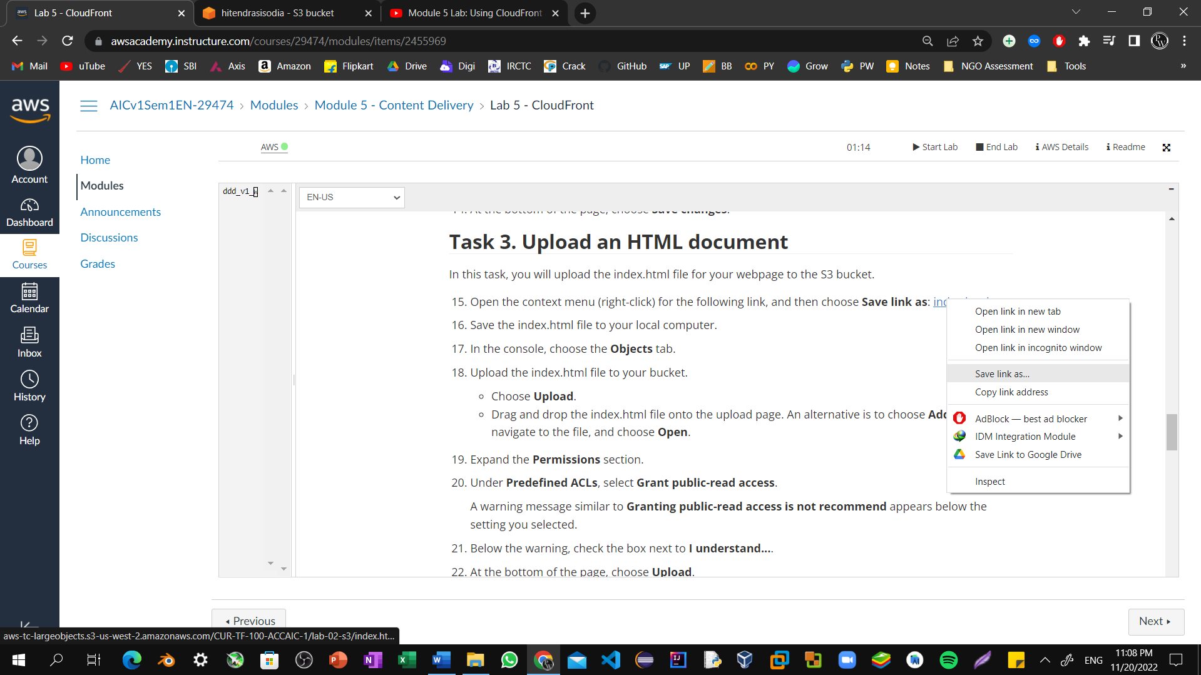

Step11: In the console, choose the **Objects** tab. Upload the index.html file to your bucket. Choose **Upload**. Drag and drop the index.html file onto the upload page.

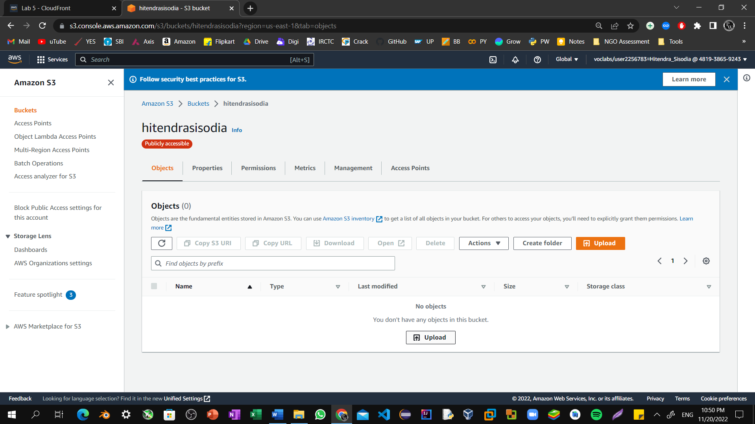

Step12: An alternative is to choose **Add files**, navigate to the file, and choose **Open**.

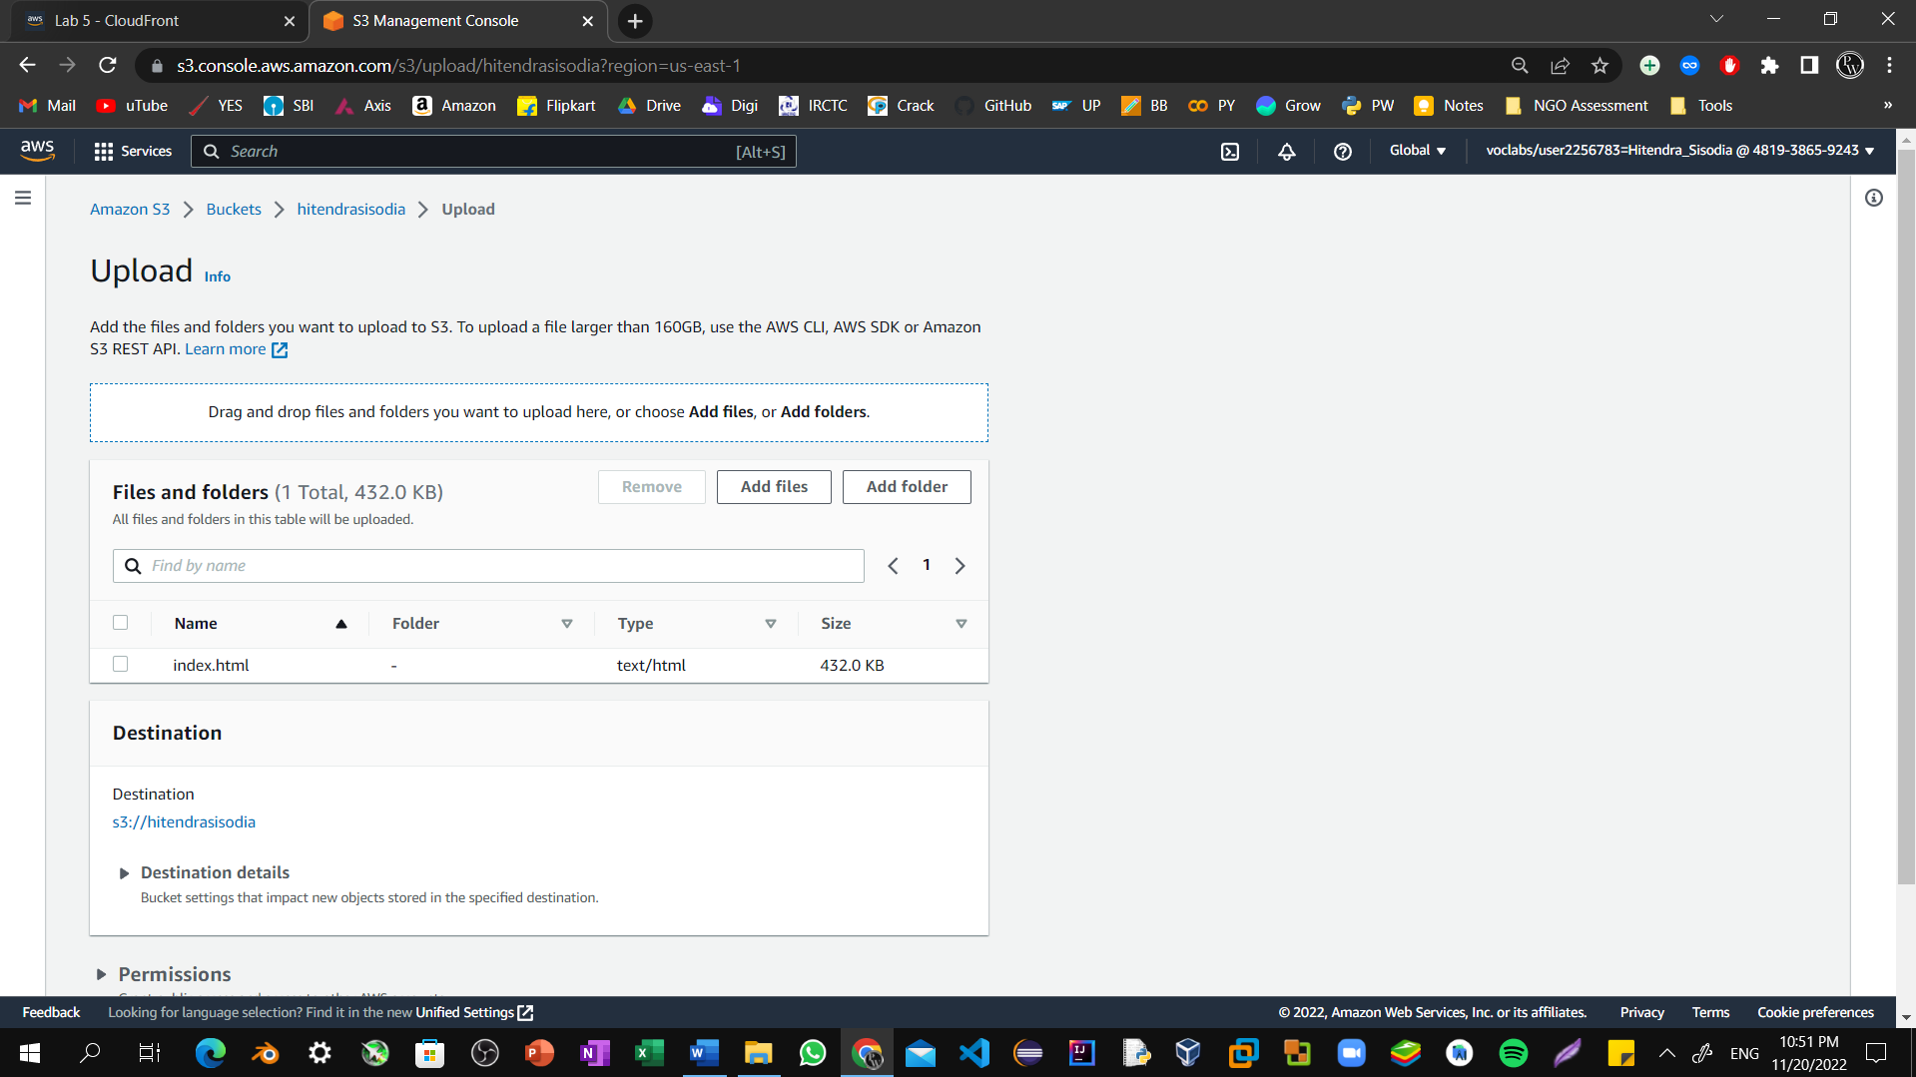

Step13: Expand the **Permissions** section. Under **Predefined ACLs**, select **Grant public-read access**. A warning message similar to **Granting public-read access is not recommend** appears below the setting you selected. 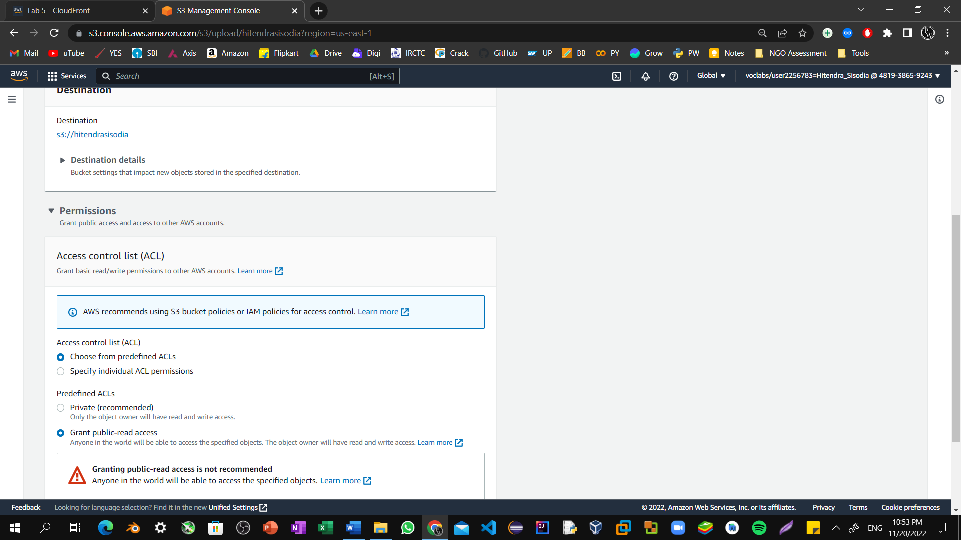

Step14: Below the warning, check the box next to **I understand..** 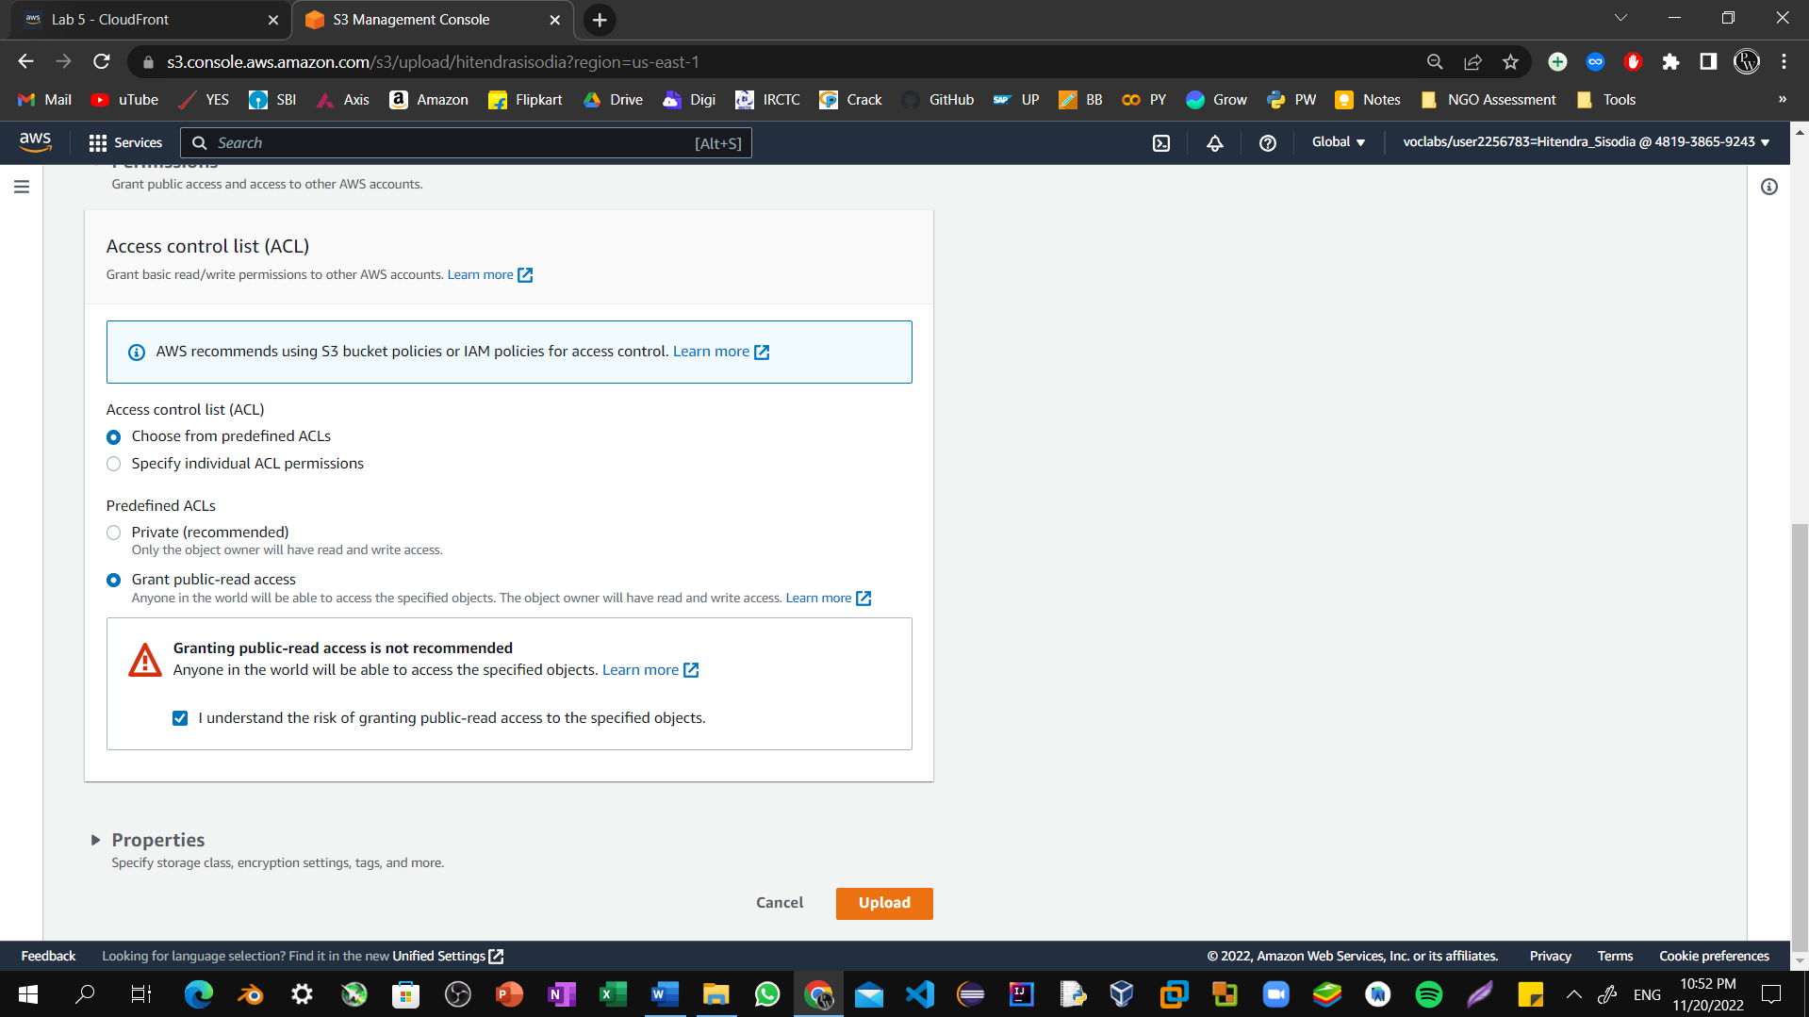

Step15: At the bottom of the page, choose **Upload**. Choose **Close**.

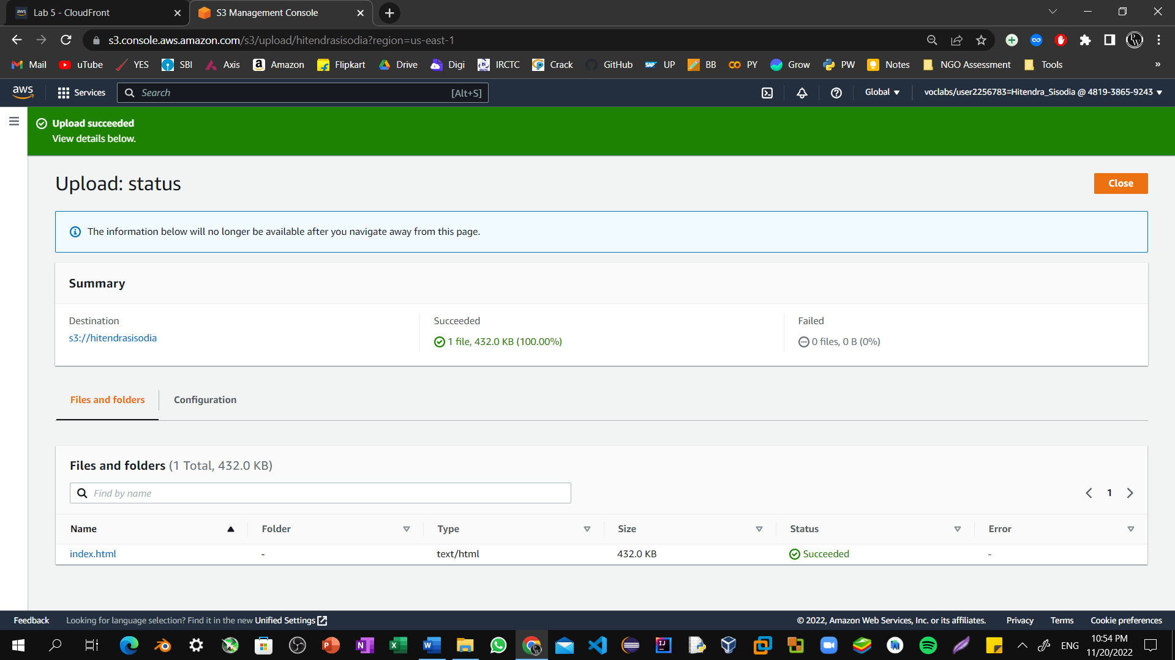

Step16: The index.html file appears in the **Objects** list.

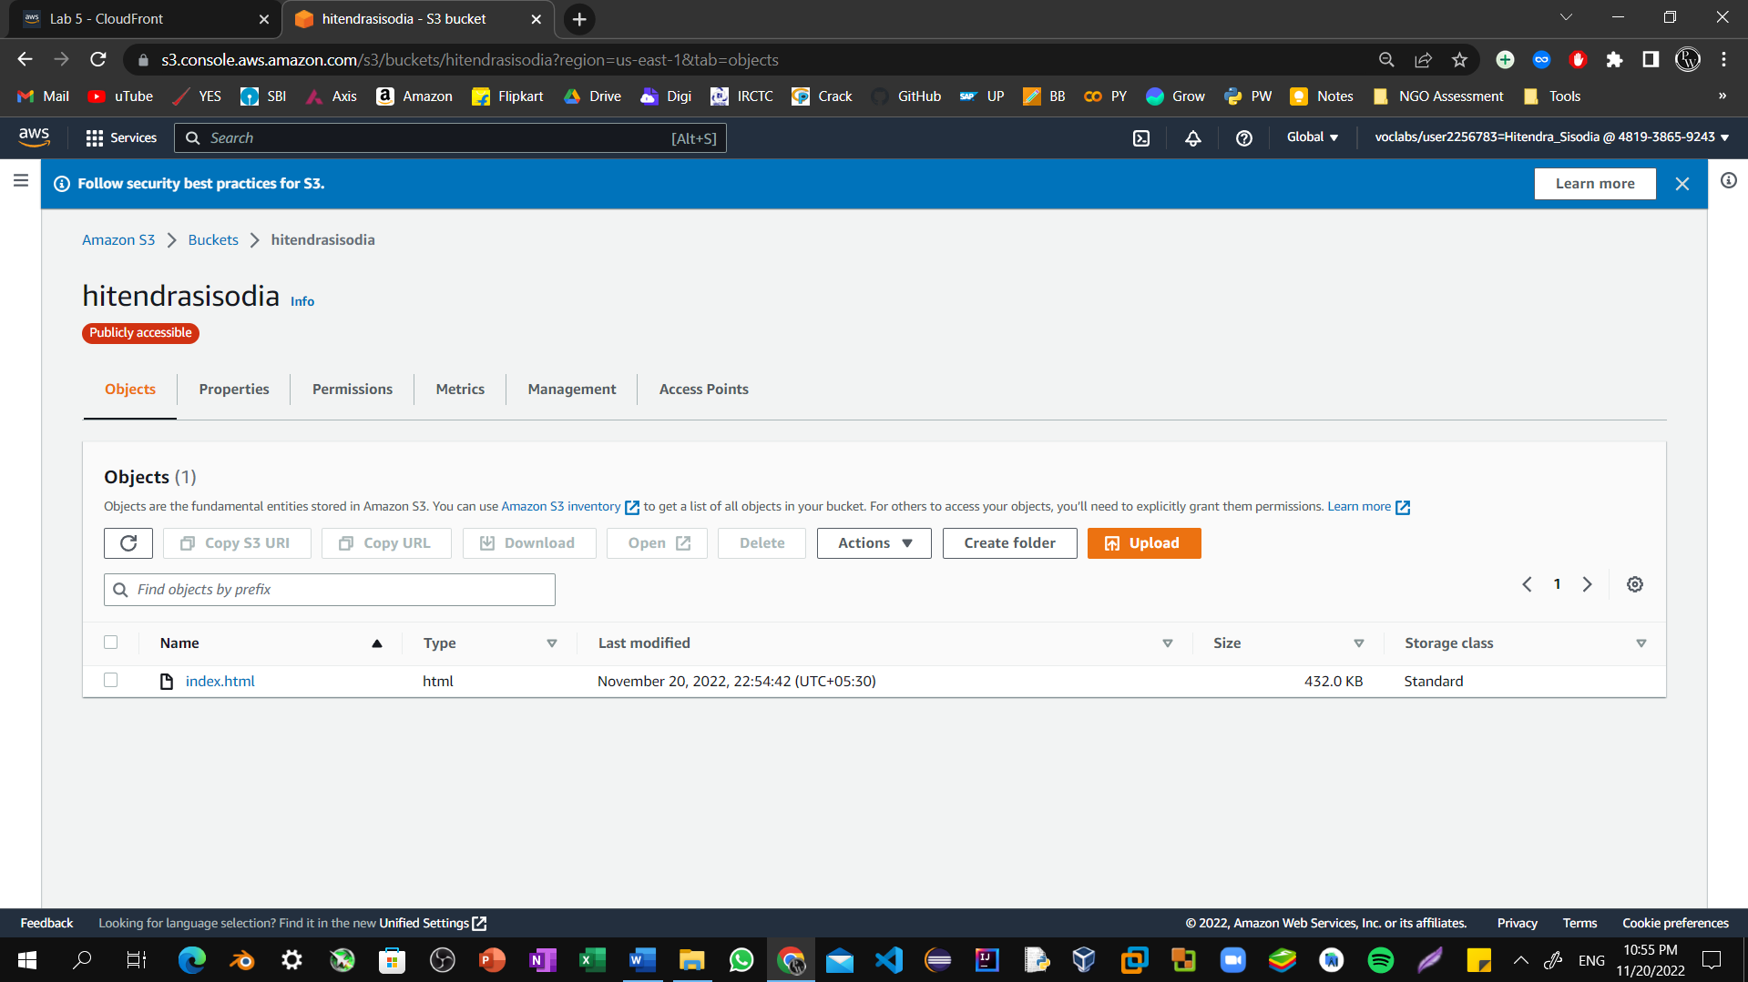

Step17: Select the **Properties** tab, and scroll down to the **Static website hosting** section. Choose **Edit**. 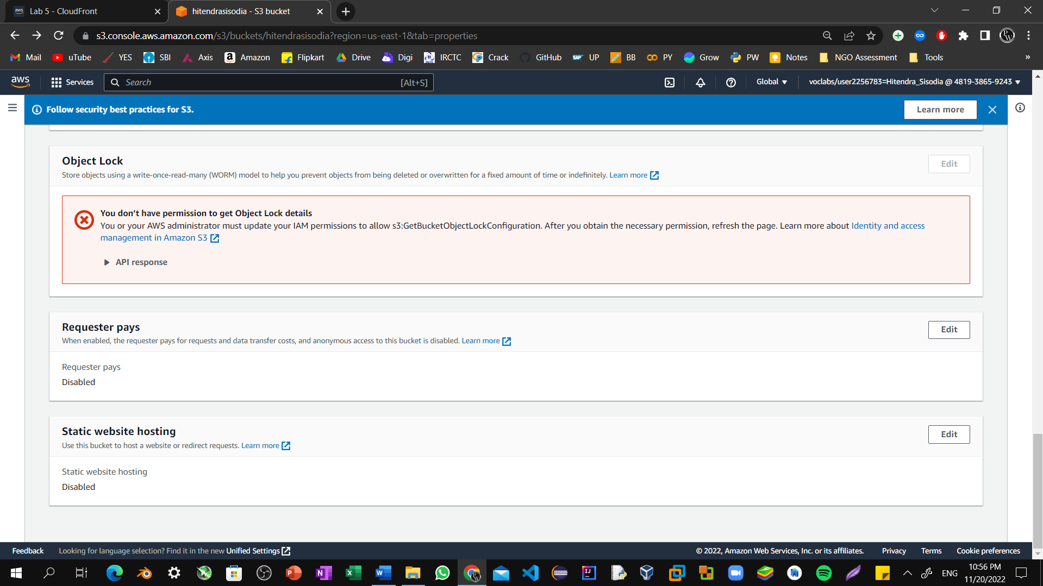

Step18: Select **Enable**. In the **Index document** text box, enter index.html

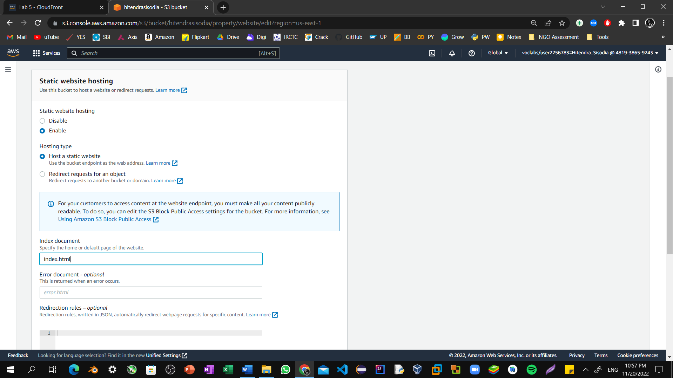

Step19: Select **Save changes**.

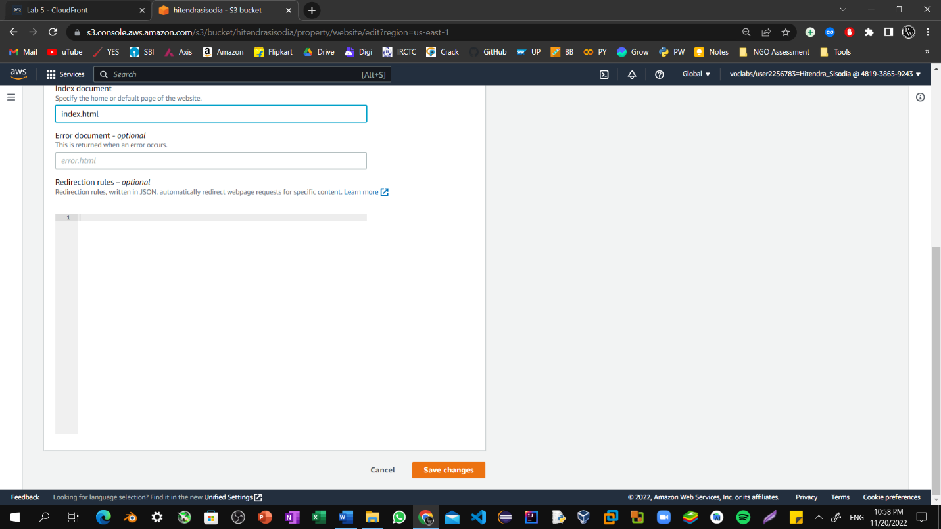

Step20: Scroll down to the **Static website hosting** section again, and copy the **Bucket website endpoint** URL to your clipboard.

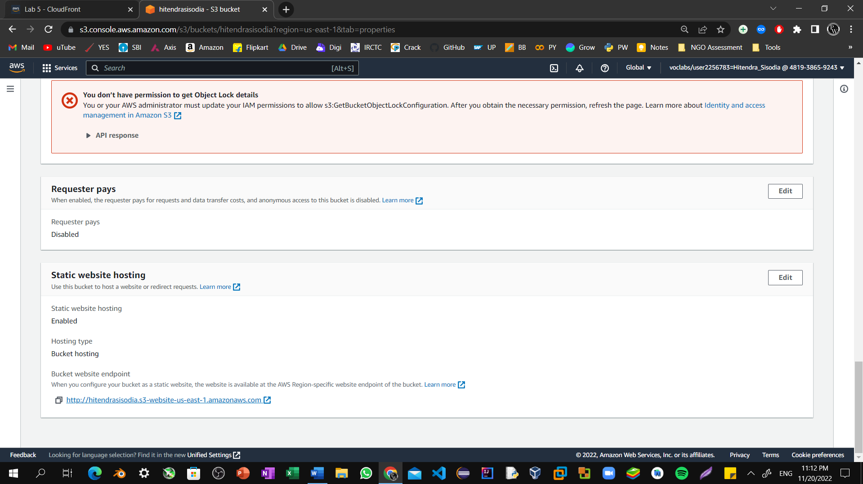

Step21: Open a new tab in your web browser, paste the URL you just copied, and press **Enter**. The **Hello World** webpage should display. You have successfully hosted a static website using an S3 bucket! 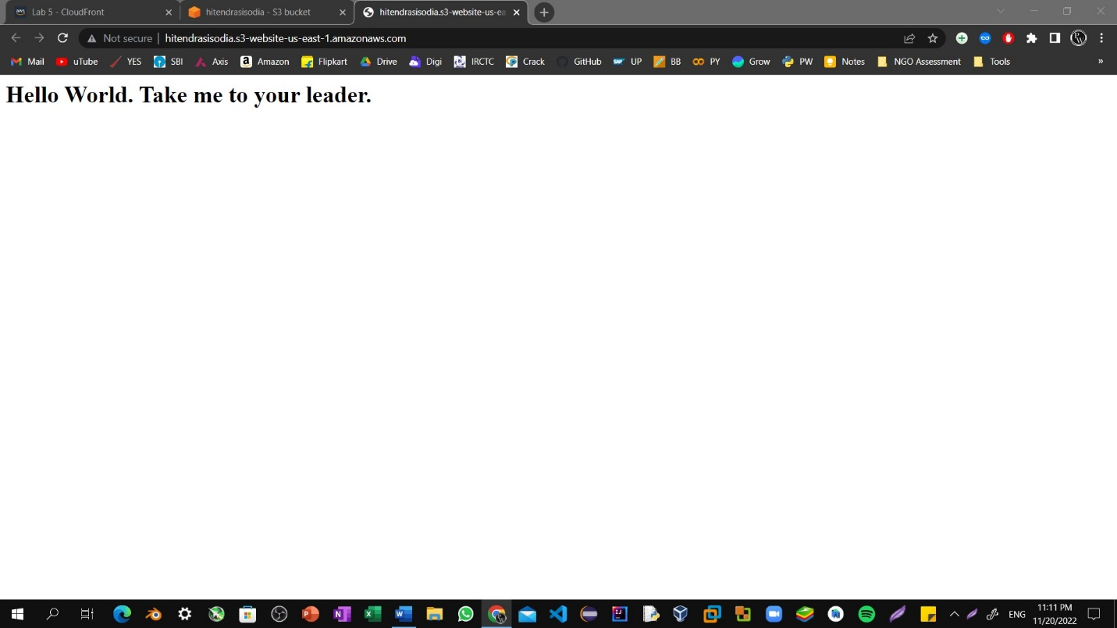

Step22: Choose the **Services** menu, locate the **Networking & Content Delivery** section, and choose **CloudFront**.

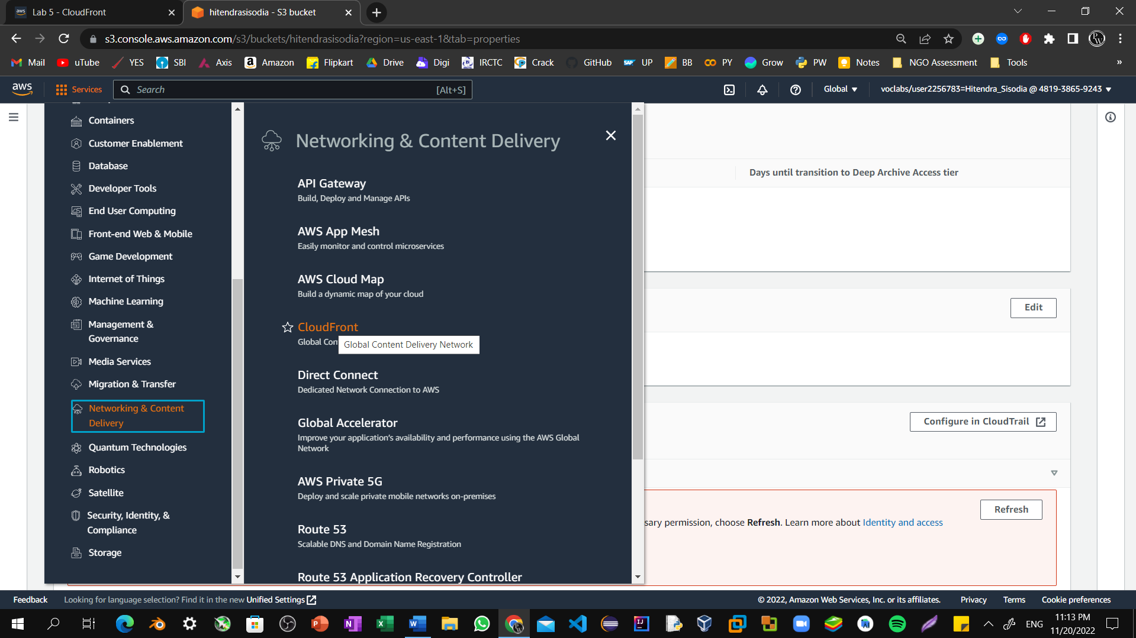

Step23: Choose **Create Distribution**.

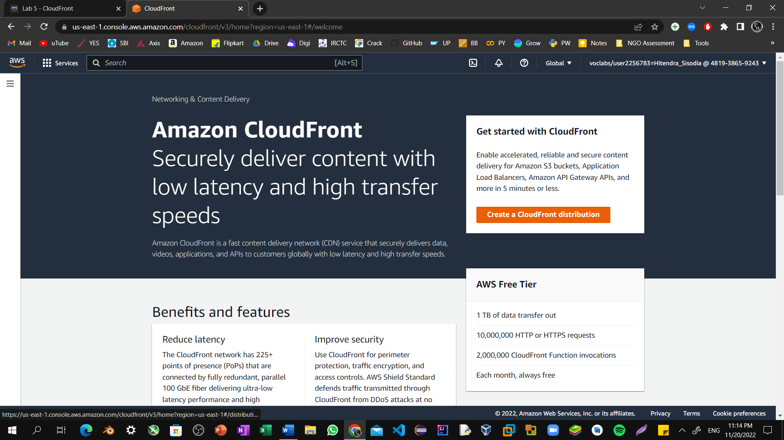

Step24: Choose the text box next to **Origin Domain Name** and select the endpoint from your S3 bucket.

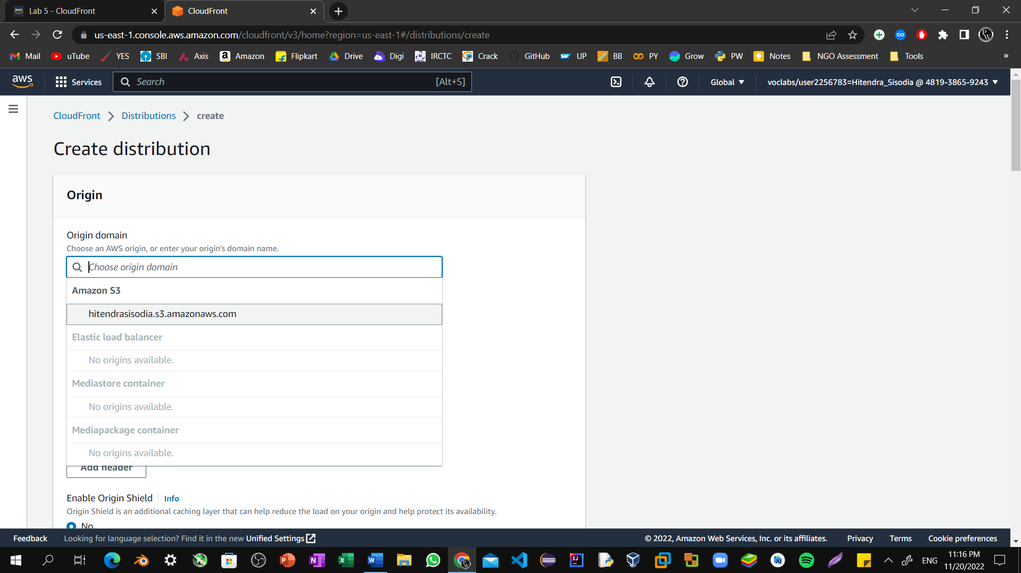

Step25: For **Viewer Protocol Policy**, ensure that **HTTP and HTTPS** is selected.

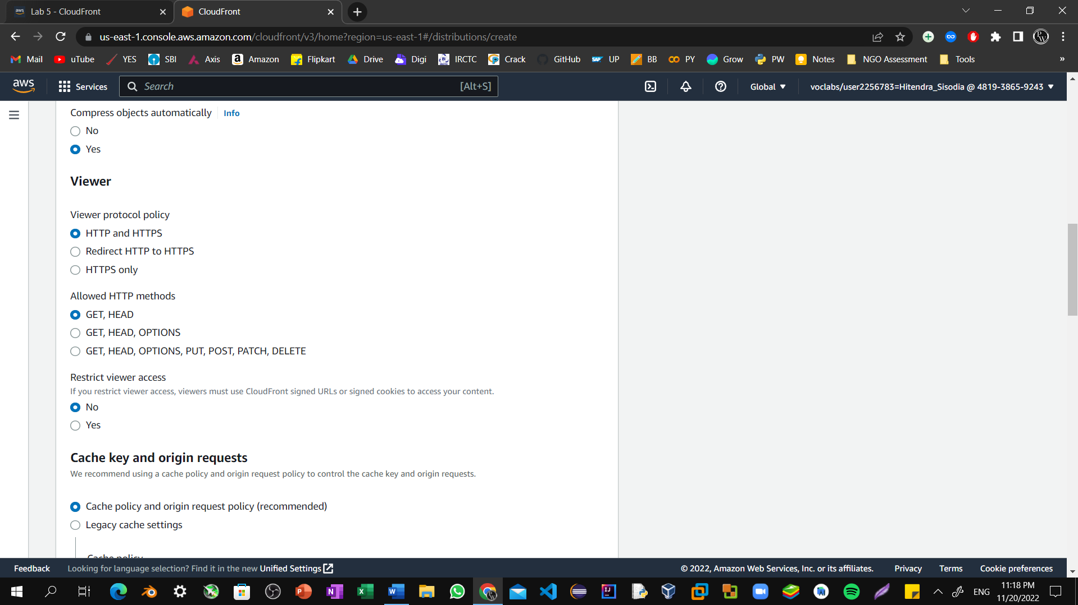

Step26: Scroll to the bottom of the page and select **Create Distribution**.

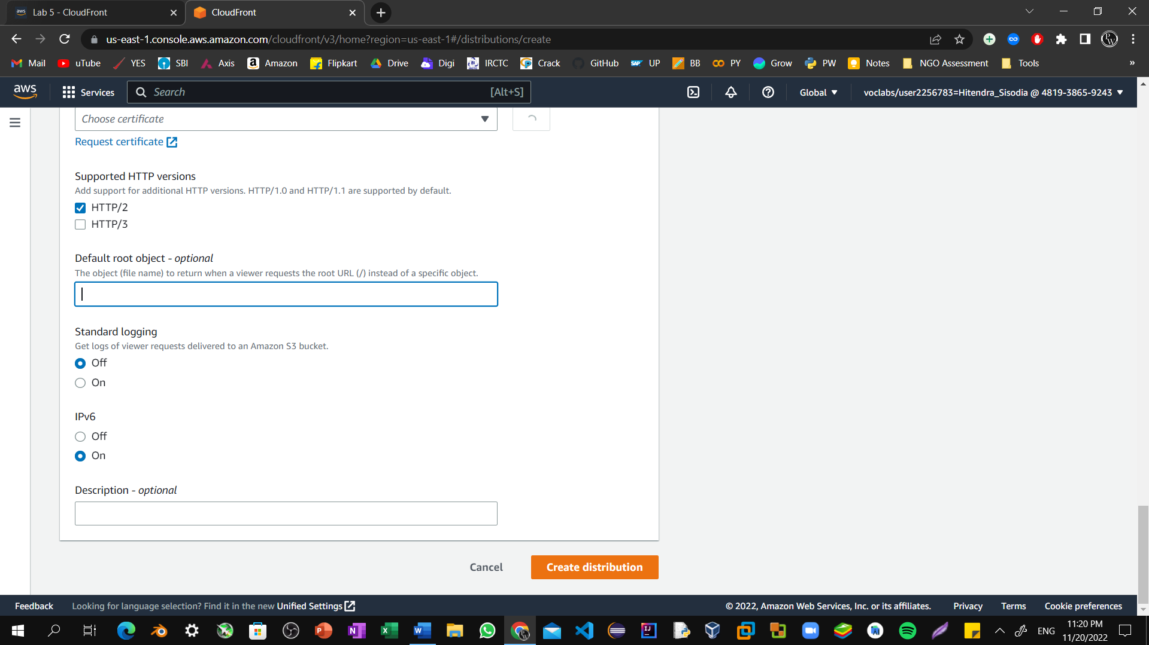

Step27: A new CloudFront distribution displays in the distributions list. The **Status** will say In Progress until your website has been distributed. This may take up to 20 minutes. When the **Status** says Deployed, you can test your distribution. 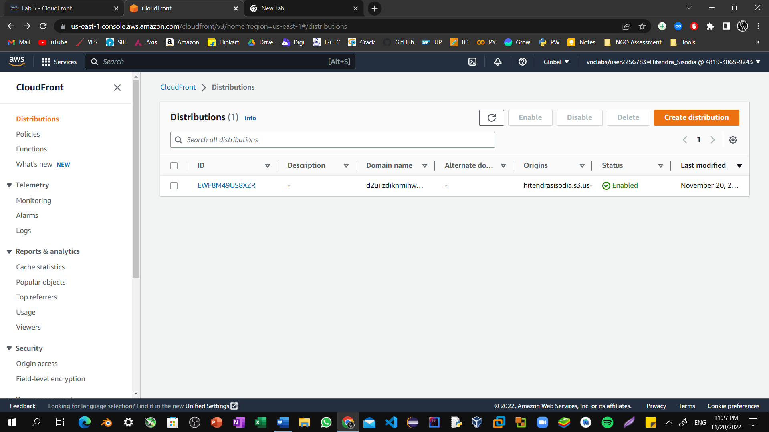

Step28: Copy the **Domain Name** value for your distribution and save it to a text editor to use in a later step.

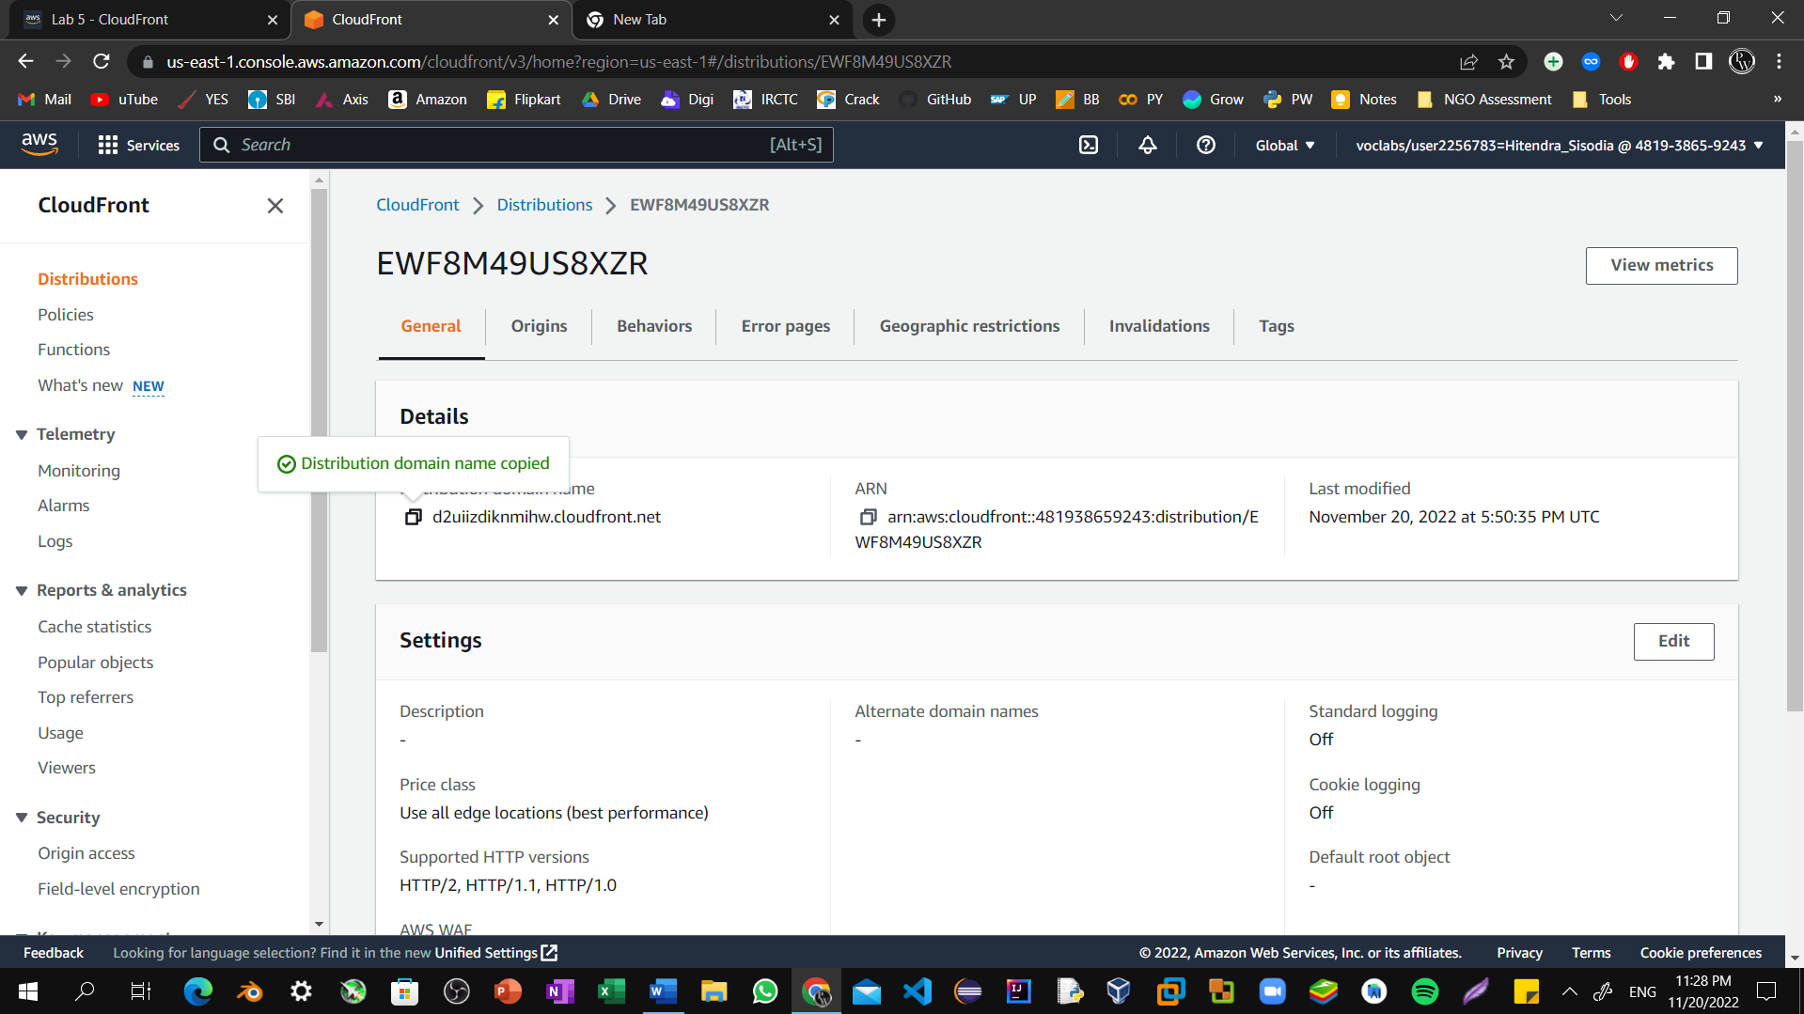

Step29: Create a new HTML file to test the distribution. Find and download an image from the internet.

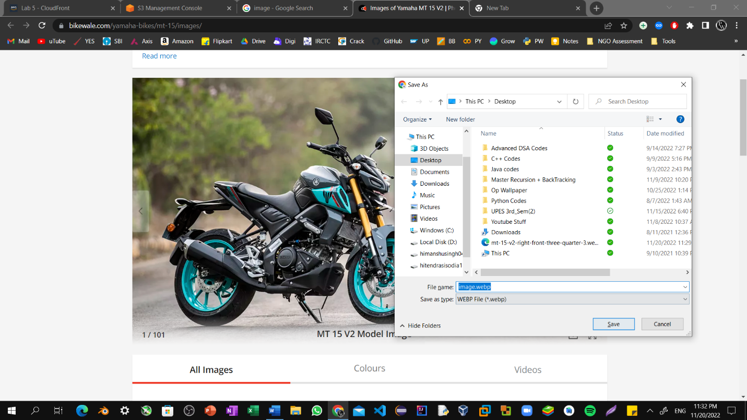

Step30: Navigate to your S3 bucket and upload the image file to it.

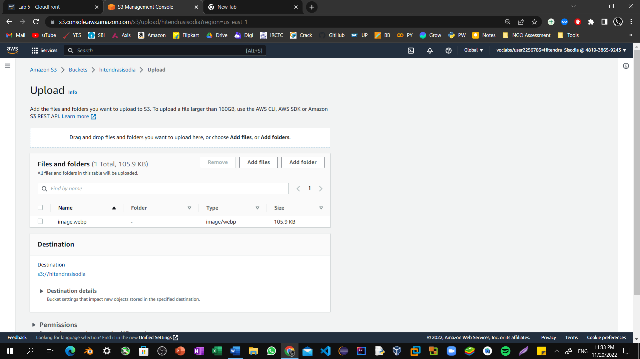

Step31: Making sure to grant public access as you did when uploading the HTML file earlier in this lab.

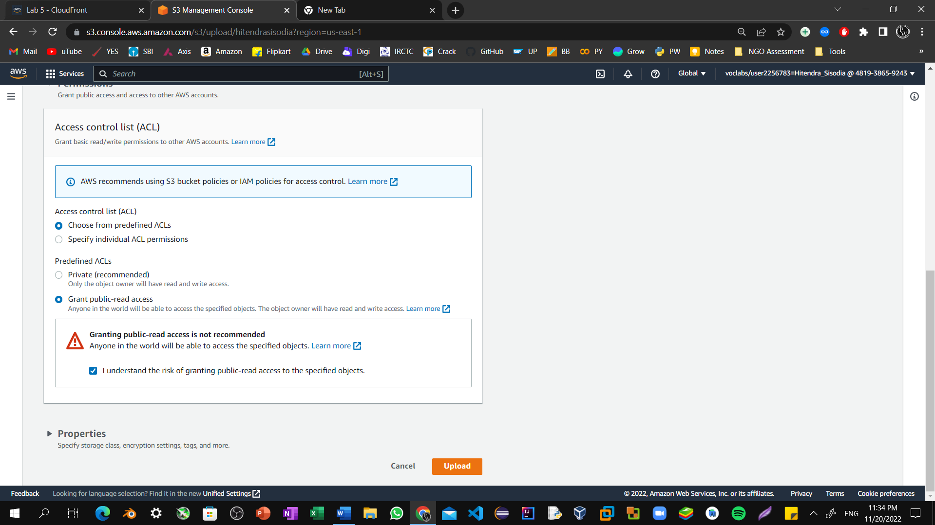

Step32: Create a new text file using Notepad and copy the following text into it.

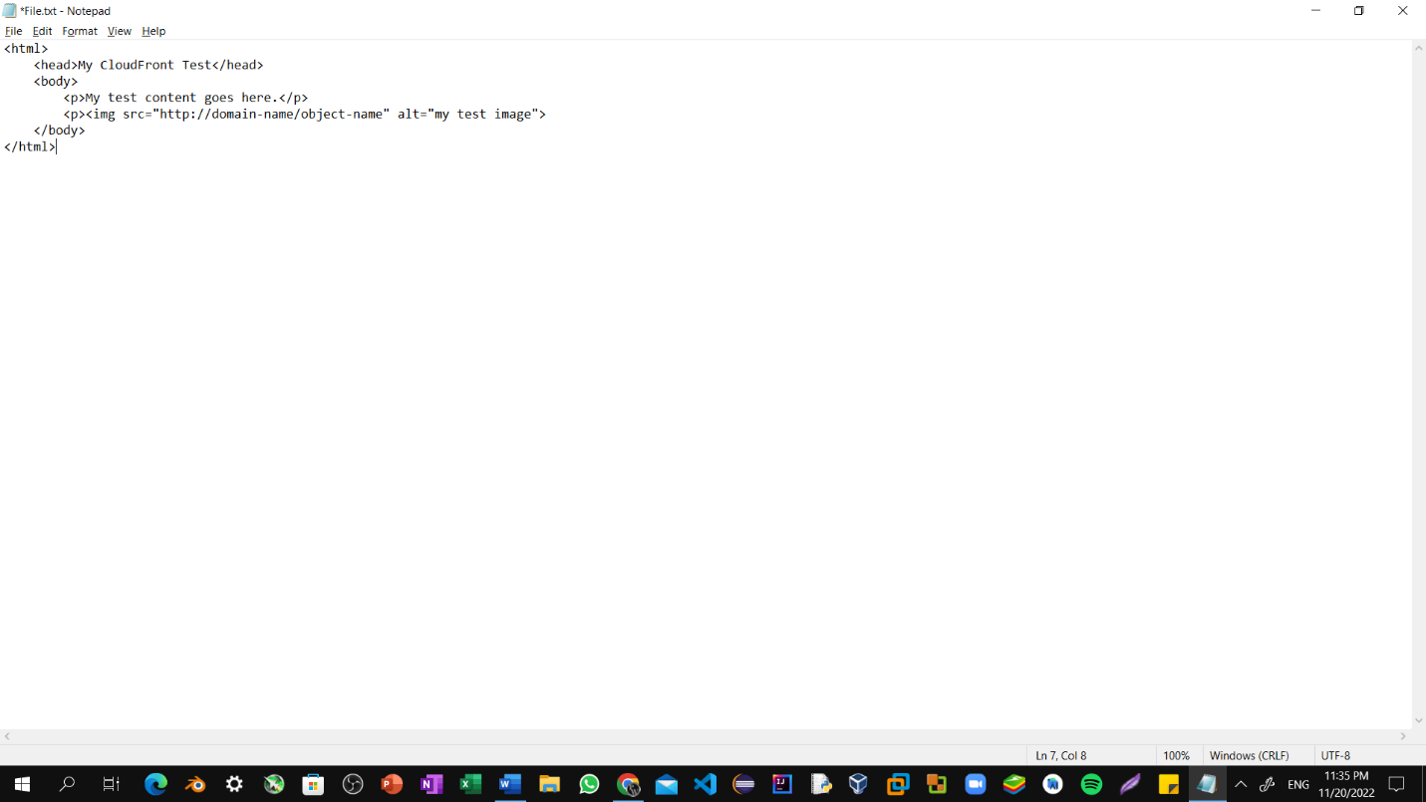

Step33: Replace **domain-name** with the domain name that you copied earlier for your CloudFront distribution. Replace **object-name** with the file name of the picture file that you uploaded to your S3 bucket.

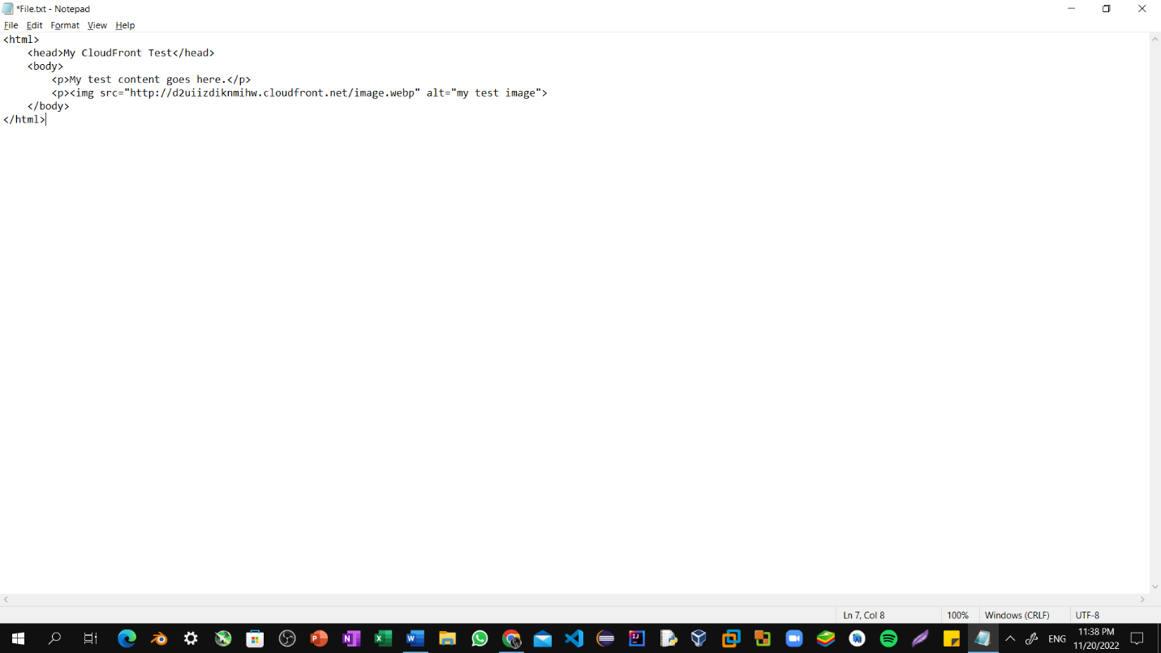

Step34: Save the text file with an HTML extension.

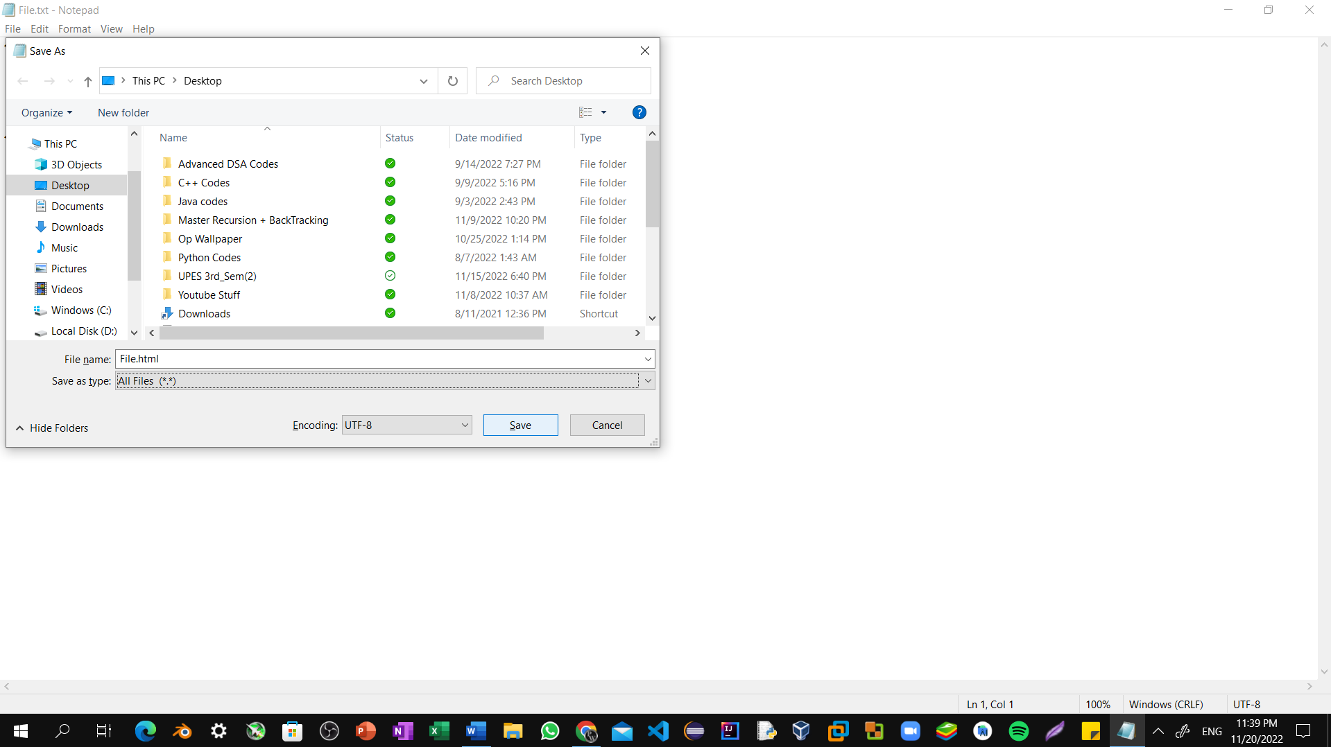

Step35: Use an internet browser to open the HTML file that you just created. If the image that you uploaded shows, your CloudFront distribution was successful. If not, repeat the lab.

